New York Times Bestselling Author
Somain Chainani
is coming to Marshall Lane Elementary!

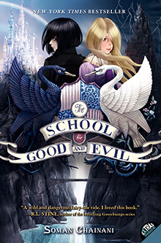

Somain Chainani has recently completed the third book in his “School for Good and Evil” trilogy and will be at Marshall Lane for a presentation about the series and a Q&A with our students. This assembly will be attended by 3rd, 4th, and 5th graders on October 21st at 10:30 in the cafeteria. All three of his books will be available to order prior to the event and each book purchased will be autographed in person by the author.

The School for Good and Evil #1
Paperback - $7.00 Number_____ Dedicated to:_________________________
Hardcover - $18.00 Number_____ Dedicated to:_________________________

The School for Good and Evil #2: A World Without Princes
Paperback - $7.00 Number_____ Dedicated to:_________________________
Hardcover - $18.00 Number_____ Dedicated to:_________________________

The School for Good and Evil #3: The Last Ever After
Hardcover only - $18.00 Number_____ Dedicated to:_________________________

Student Name_____________________________ Teacher/Room #________________

Parent Name___________________________ Parent email_______________________

Completed forms with payment are due Friday, 10/16. Checks should be made payable to “Hicklebee’s” If more then one of the same book is ordered, please specify on the back of this form to whom each book should be dedicated. Please contact Mrs. Steele if you have any questions or concerns – (408) 341-7000 x4457 or ansteele@campbellusd.org.

